PI CALCULATION PROJECT

Author: Tu Nguyen

Contents
Author: Tu Nguyen 1
Introduction 3
✓ Requirement 3
✓ Goal 3
✓ Scope 3
This document is only a simple practice. 3
Architecture 3
✓ Algorithm solution 3
✓ Producer and consumer Pattern 4
✓ Class Diagram 4
i. Main class 4
ii. CalculationImpl class 4
iii. CalculationConfigurationImpl class 5
iv. ProducerImpl class 5
v. ConsumerImpl class 5
vi. Calcultion interface 5
vii. CalculationConfiguration interface 5
Hand on lab 5
✓ Setup Environment 5
✓ Build and run 5

Introduction
  - Requirement
Use the following formula to calculate Pi value

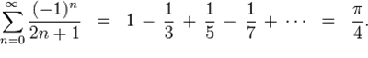

  - Goal
This document describes the solution for calculating approximate value of the constant Pi (π). It also provides the instruction to build and run the application.
  - Scope

This document is only a simple practice.

Architecture
  - Algorithm solution
From the above formula I rewrite the formula
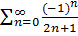 = 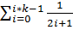 - 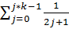
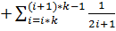 - 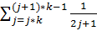
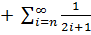 - 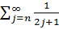
With i = 2n and j = 2n + 1, then
− + 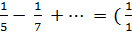 - + - + 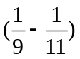 =
=
The code implementation follows by the formula rewritten.
  - Producer and consumer Pattern
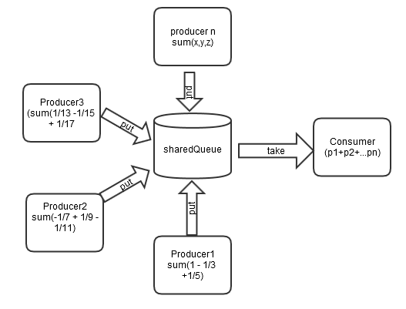

  - Class Diagram

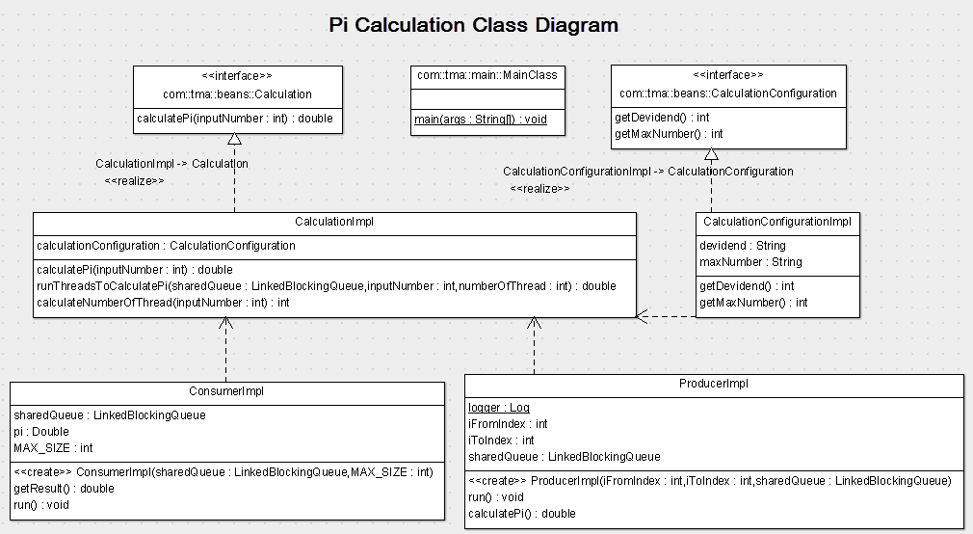

- Main class
This class allows users input the correct number, and then returns an approximation to the constant Pi (π). If the input number is wrong, user must be input again.
- CalculationImpl class
This class provides the method calculatePi to calculate the constant Pi base on the input number. We use the thread pool to submit all producers and the consumer. Producers using for calculating value on each part, and put the result to sharedQueue. The Consumer is using for getting all values from the sharedQueue, calculating and return Pi after calculation.
- CalculationConfigurationImpl class
This class provides methods to get calculation configuration from properties file.
- ProducerImpl class
This class provides producers which calculating and setting value for the sharedQueue
- ConsumerImpl class
This class gets and calculates all items from the sharedQueue. It also provide the method getResult to get Pi after calculation
- Calcultion interface
This interface provide the calculationPi method to calculate the Pi constant
- CalculationConfiguration interface
This class provides all methods to get configurations from properties file

Hand on lab
  - Setup Environment
Enviroment must be set JAVA_HOME and MAVEN_HOME.
  - Build and run
- Built the application using Maven: mvn clean install ${PATH}/ calculatingPi
- All the result will be stored in {project root}/target folder.
- Run CalculatingPI.jar file: java -jar target/CalculatingPi-0.1.jar
- Input values and see results.

